Math 1309 Quiz 6 – Spring 2012
Name:
Show all your work and always use correct mathematical notation.

Determine the following limits, use or when appropriate. Use L’Hopital’s rule when needed.

a) 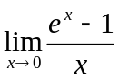

b) 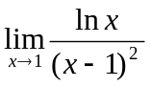

c) 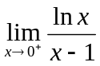

d) 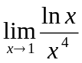

e) 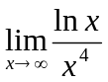

f) 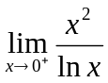

g) 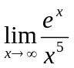

h) 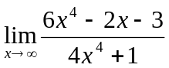

2. Use the information in the charts to sketch the graph of the function f
x
x | -2 | -1 | 0 | 2 | 3
f(x) | 0 | 1 | 0 | 3 | 0

f ‘
+ + + + - - + + + - - -
x
-2 -1 0 1 2

- - + - - - + + - - - -
f “
x
-2 -3/2 -1/2 1

2. Sketch the graph of the given function by doing the following
1. Determine the domain of the function and the equations of all the vertical and horizontal asymptotes. Show the limits to find the asymptotes, full credit will only be given if limits are shown and correctly calculated.
2. Find all the critical points (both coordinates) and determine the intervals where the function is increasing and the ones where it is decreasing. Classify each critical point as a local max, min, or neither
3. Find the inflection points (if any) and determine the intervals where the function is concave up and the ones where it is concave down
4. Determine the x- and y-intercepts (if any)
7. Use this information to graph the function. Your graph must clearly show all the information found above. Graphs from a calculator will receive not credit

a) 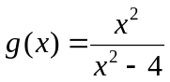
x

b) 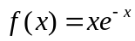 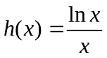
x

